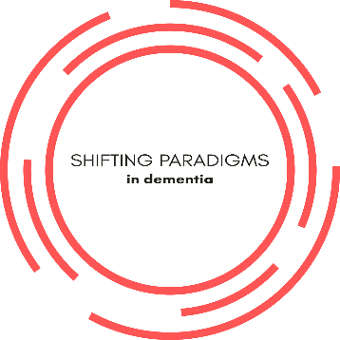
“Shifting paradigms for dementia: Involving people living with dementia across research, policy and practice”.

Friday 13th October 10am-4pm.
Scottish Universities Insight Institute,
Collins Building, 22 Richmond St, Glasgow, G1 1XQ.

Workshop 1. Shifting paradigms: The politics of dementia in an era of uncertainty

The goal of this programme is to ‘shift paradigms’ within dementia, by challenging current thinking and practice through collaboration and the involvement of people with dementia. This seminar series will forge partnerships between people with dementia, communities and universities in order to promote the sustainable development of dementia friendly communities, policy and research.

The first seminar is led by organisations of people living with dementia and focuses on the gap between policy and the realities that people living with dementia face in Scotland and beyond.

10.00-10.15am Introduction to the seminar series
Dr Grant Gibson. University of Stirling. Dr Diane Pennington. University of Strathclyde. Dr Sue Northrop. Dementia Friendly East Lothian

Morning session – Dementia, citizenship, and everyday life– experiences of people with dementia

10.15-10.45am Session 1. – Dementia and experiences of engaging with the state.
Joy Watson. Dementia Diaries.
10.45-11.15am Session 2. – Experiences of the Dementia assessment
Agnes Houston MBE. Dementia Alumni and Scottish Dementia Working Group
11.15-11.30 am Coffee Break
11.30-12.30 pm Morning workshop. Critiquing dementia friendliness, perspectives from everyday
life

12.30-1.30 pm Lunch

Afternoon session – continuing to promote citizenship and dementia in Scotland

1.30-2.00 pm Session 3. - Starting with Rights: looking through the other end of the telescope. Philly Hare. Director, Innovations in Dementia
2.00-2.30 pm Session 4. – the Scottish Dementia Strategy - reactions from DEEP groups"
Paul Thomas. Dementia Engagement and Empowerment project
2.30-2.45 pm Coffee Break
2.45-3.45pm Afternoon Workshop – putting right based approaches to the test in Scotland

3.45-4.00 pm Concluding comments
Dr Grant Gibson. University of Stirling

